Intensity-level slicing
code:
import cv2
import numpy as np

image = cv2.imread('beyin.jpg')
if image is None:
exit()
gray_image = cv2.cvtColor(image, cv2.COLOR_BGR2GRAY)
lower_bound = 100
upper_bound = 200
sliced_image = np.zeros_like(gray_image)
sliced_image[(gray_image >= lower_bound) & (gray_image <= upper_bound)] = 255

cv2.imshow('Original Image', image)
cv2.imshow('Intensity-Level Slicing', sliced_image)
cv2.waitKey(0)
cv2.destroyAllWindows()
Code Explanation:
- The image 'beyin.jpg' is loaded.
- The image is converted to grayscale to simplify the process.
- Intensity level slicing is applied by setting a range of pixel values to keep (between 100 and 200 in this case). Pixels outside this range are set to zero (black), while those within the range are set to 255 (white).
- The resulting image is displayed alongside the original.

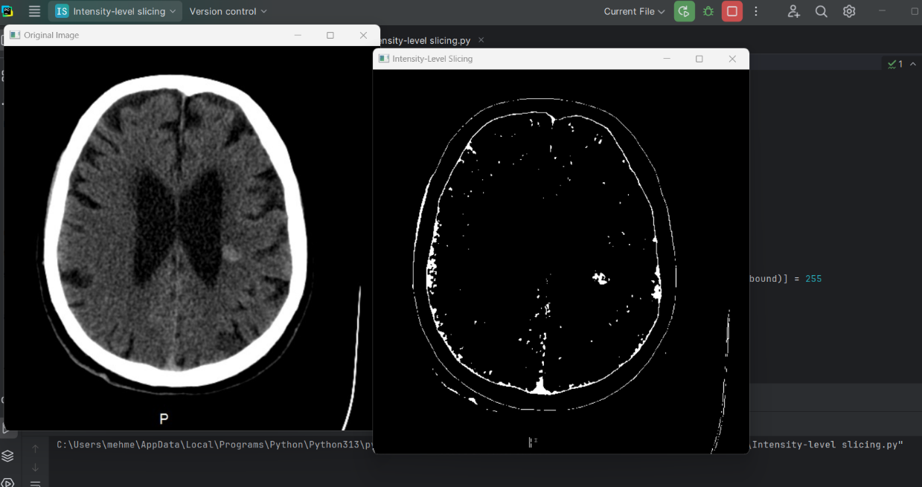
Output:

Report:
This code demonstrates intensity-level slicing, a technique used to isolate and highlight a specific range of pixel values in an image. The technique is particularly useful for emphasizing certain features in an image based on their intensity levels.
The image is first converted to grayscale, and then intensity levels within a specified range (100 to 200) are kept, while all other pixel values are turned to black. This creates a binary image that highlights the features with intensities in the defined range. The resulting image is displayed alongside the original for comparison.
Intensity-level slicing can be useful in medical imaging, satellite image analysis, and other fields where certain intensity ranges need to be emphasized for further analysis or visualization.

